Year 5 Autu,mn 1 RE – Hinduism
Key facts  - Hinduism is one of the oldest religions in the world. It began about 5000 years ago, linked to the people who lived near to the Indus River in about 2500 BC.  - Hinduism has no single founder or prophet. The Hindu faith draws on several sacred texts and there is no standard set of beliefs,  - All Hindus believe that life, death and rebirth are a continuous process that we are all part of.  - Hindus believe that there is a part of Brahman in everyone and this is called the Atman.  - Samsara means going through the cycle of repeated births and deaths (reincarnation). Hindus believe that existence of this cycle is governed by Karma.  - The most ancient sacred texts of the Hindu religion are written in Sanskrit and called the Vedas. | 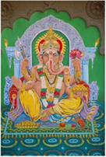  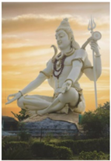  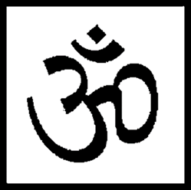  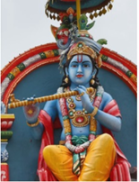  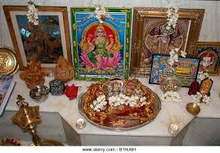  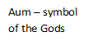  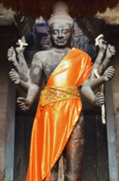  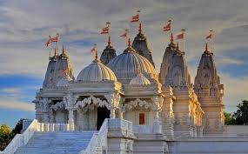  Shrine  Krishna  Mandir
 | Vocabulary  - Brahma  - Vishnu  - Shiva  - Trimurti  - Dharma  - reincarnation  - moksha  - samsara  - karma | - The spiritual goal of a Hindu is to become one with Brahma. This freedom is referred to as moksha. Until moksha is achieved, a Hindu believes that they will be repeatedly reincarnated in order that they may work towards self-realization of the truth.  - Moksha - the release of the soul (Atman) from the cycle of rebirth. The individual soul (Atman) unites with Brahman the universal soul.  - Dharma - the code for leading one's life. Respect for elders is considered important.  - Karma- through pure acts, knowledge and devotion, you can reincarnate to a higher level. The opposite achieves the opposing result.

