Year 4 Autu,mn 1 RE – Hinduism
Key facts  - Hinduism is one of the oldest religions in the world. It began about 5000 years ago, linked to the people who lived near to the Indus River in about 2500 BC.  - Hinduism has no single founder or prophet. The Hindu faith draws on several sacred texts and there is no standard set of beliefs,  - Many gods are worshipped in Hinduism. Each Hindu god is said to be a different part of the supreme God ‘Brahman’.  - Hindus believe that God can be seen in a person or an animal. They believe that God is in everybody.  - The main three aspects  (Trimurti) are:  Vishnu, Brahma and Shiva  - Hindus can pray to different  gods and goddesses for help with  different needs.  - Brahma is said to be the creator of the whole universe  - Vishnu is the preserver god, which means he protects the earth  - Shiva is known as the destroyer god because he removes all evil from the world.  - Hindu worship, which is known as “puja,” takes place in the Mandir. | 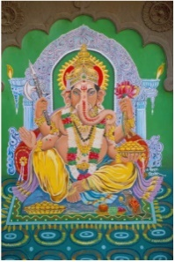  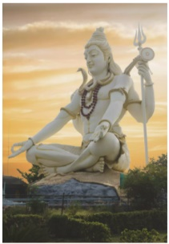  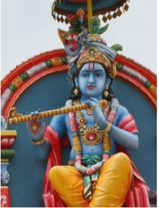  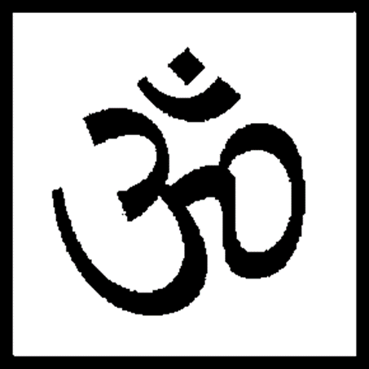  Krishna  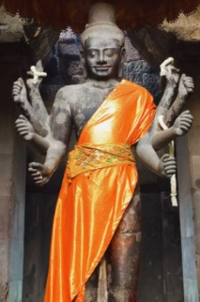  Aum – symbol of the Gods  Vishnu  Ganesh  Shiva  Krishna
 | Vocabulary  - Brahma  - Vishnu  - Shiva  - Trimurti  - Dharma  - reincarnation  - Moksha  - puja | Some Hindu gods and goddesses:  Brahma, the Creator.  Vishnu, the Preserver.  Shiva, the Destroyer.  Ganapati, the Remover of Obstacles.  Avatars of Vishnu.  Saraswati, the Goddess of Learning.  Lakshmi.  Durga Devi.

