Year 1 Computing Knowledge Organiser: Unit 1.3
Pictograms
Key Images | Key Vocabulary
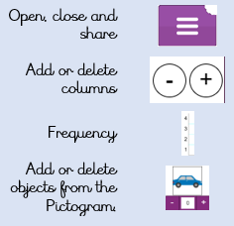 | - Pictogram  - Diagram  - Data  - Facts  - Statistics  - Collate,  - Information,
Key Questions | Key Learning
In what ways can we use pictograms?  You can use a pictogram whenever you want to make simple data more visually interesting, more memorable. Or more engaging. | - To understand that data can be represented in picture format.  - To contribute to a class pictogram.  - To use a pictogram to record the results of an experiment.

