Year 4 Autumn 2 PSHCE – Healthy Eating
Key information  - There are many ways for us to stay healthy.  - Eating healthy foods and regular exercise help to keep us healthy.  - We should aim to eat 5 portions of fruit and vegetables a day.  - Eating a lot of unhealthy food could make us overweight and unhealthy.  - It is important to have a balanced diet. | 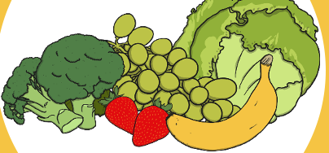  healthy  unhealthy  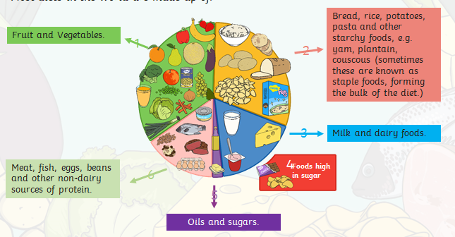
Vocabulary
- healthy
- unhealthy
- protein
- dairy
- choices
- fruit
- vegetables

