Year 2 Autumn 2 PSHCE – Health and Safety
Key information  - There are many ways for us to stay healthy.  - Eating healthy foods and exercising regularly help to keep us healthy.  - Being positive and getting enough sleep also help to keep us healthy.  - We should aim to eat 5 portions of fruit and vegetables a day.  - Eating a lot of unhealthy food could make us overweight and unhealthy. | 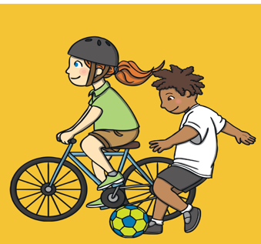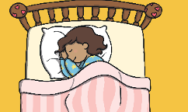  sleep  unhealthy  exercise  happy attitude  healthy
Vocabulary
- healthy
- unhealthy
- exercise
- like
- dislike
- choices
- sleep
- healthy eating
- fruit
- vegetables

