Year 5 Autumn 2 Art – Textile: Exploring Wool
Key facts  - Wool is a natural textile that comes from sheep  - The sheep wool is sheared and then spun to make yarn  - Historically this would have been done on a spinning wheel, but today it is done with machinery  - As well as clothing, wool is used for blankets, rugs, carpets, insulation and upholstery  - you can knit, weave, crochet or sew with wool  - Natural wool is dyed to make many different colours  - When sewing with wool you need a needle with a larger eye | 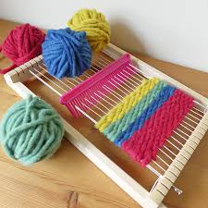  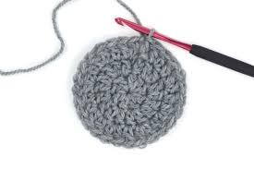  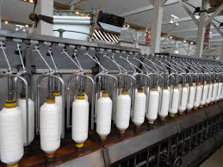  people weave on a loom  crochet  knitting  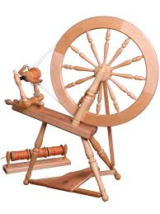  yarn spinning machine  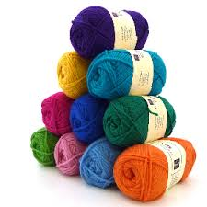  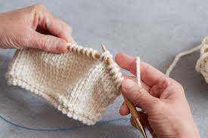  wool balls  spinning wheel
 | Vocabulary  - wool winding  - yarn  - natural forms  - manipulated  - taut  - weave  - spinning wheel  - dye | Make your own pom pom  - take two circles of strong card, with holes cut in the middle  - the bigger the hole the larger the pom pom  - wind wool, close together around the card until there is no whole  - carefully cut the wool between the card and tightly wrap and tie wool round the middle  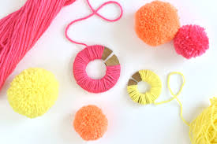  - cut the card off  