Year 4 Autumn 2 Art – Painting: Landscapes
Key facts  - Landscape painting is also known as landscape art  - A landscape painting or drawing refers to an artwork whose primary focus is naturally scenery  - The artwork may include forest, rivers, mountains, valleys, cliffs etc.  - John Constable was an English landscape painter  - He lived from 1776 to 1837 and painted in the Romantic style  - Claude Monet was a French landscape painter. He is very famous for painting waterlilies  - He lived from 1840 to 1926 | 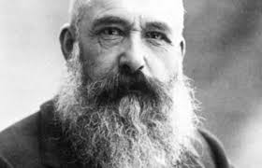  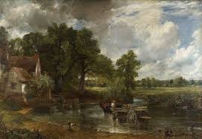  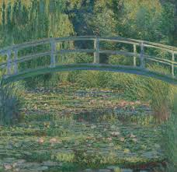  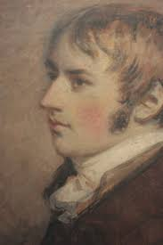  Claude Monet  comic strip  Example of landscape painting – John Constable  John Constable  The Waterlily Pond – Claude Monet
 | Vocabulary  - landscape  - scene  - setting  - natural  - rural  - urban  - townscape  - seascape  - Impressionist  - imaginary  - realistic | When using watercolours…  - you can wet the paper and then add paint onto the wet area  - wet you brush and use the paint on the dry paper  - more water means the paint will be thinner and create more of a colourwash  - less water means the colour is bolder and stronger

