Year 4 Autumn 1 PSHCE – Loss & Seperation
Key information  - When we lose something , it can become frustrating .  - When we lose someone special to us, we grieve.  - People grieve differently.  - People can experience different emotions when they lose someone.  - Being separated from someone you care about can be scary.  - There are different people to help support us when we lose someone. | 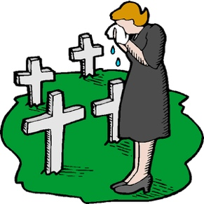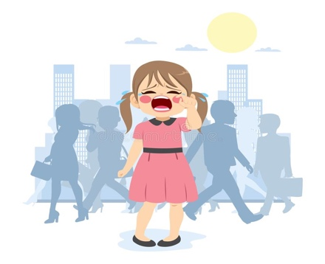  separated  upset  bereavement  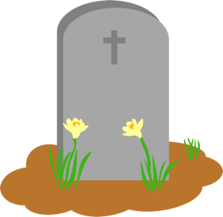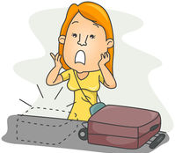  misplace  misafter each pets  death
 | Vocabulary  - loss  - misplace  - cope  - grief  - emotions  - bereavement  - death  - support  - hurt  - separated | 