Year 4 Autumn 1 Humanities – European Cities
Key facts  - Physical feature is something that is naturally created.  - Human feature is something that is built by humans.  - A country is a nation with its own government.  - A city is a large human settlement.  - A capital city is a city or town that functions as the seat of government and administrative centre of a country or region.  - A continent is one of several very large landmasses.  - Europe is the world's second smallest continent after Australia. Asia is the world's largest continent.  - The European continent houses 50 countries.  - The European continent is located in the northern hemisphere.  - The Volga River in Russia is Europe's longest river.  - Europe borders onto the Arctic Ocean, the Atlantic Ocean and the Mediterranean Sea. | 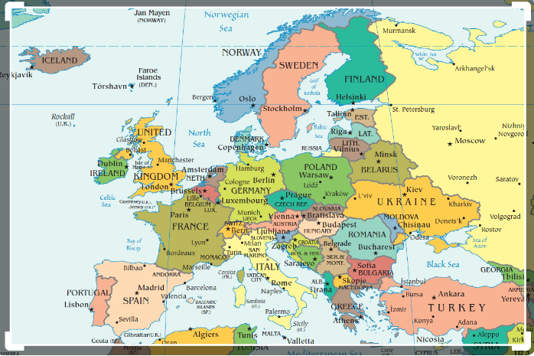  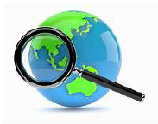
 | Vocabulary  - Europe  - Madrid  - Rome  - London  - Stockholm  - Oslo  - Berlin  - Moscow  - physical feature  - human feature  - mapping/climate | 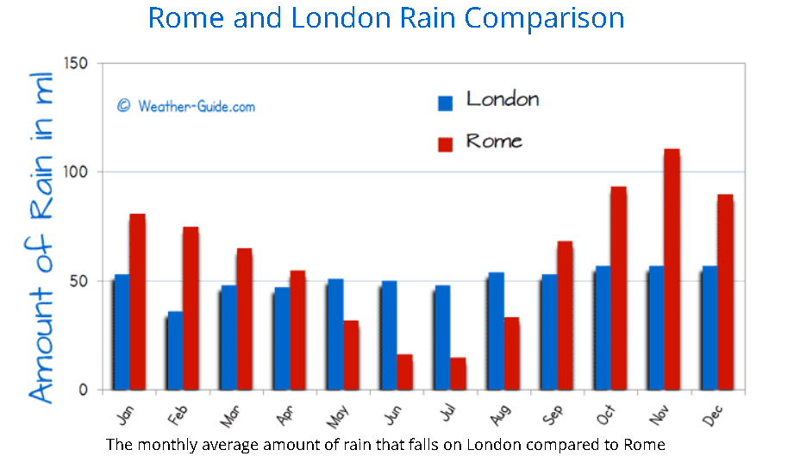  Weather pattern

