Year 3 Autumn 1 Humanities – Changes in Britain from the Stone Age to the Iron Age
Key facts  - The Stone Age was a broad prehistoric period during which stone was widely used to make implements with an edge or a point.  - The Bronze Age is the time period when people made tools from an alloy called bronze.  - The Iron Age is the name given to the time period where iron became the choice of metal to make tools.  - Chronological means arranging events in their order of occurrence in time.  - Stonehenge is a prehistoric monument in Wiltshire, England.  - Danebury is an Iron Age hill fort in Hampshire, England. | 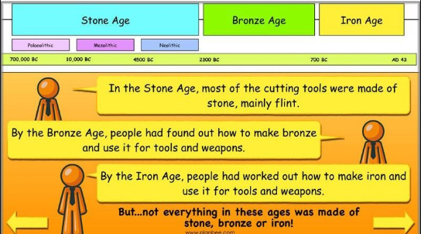
 | Vocabulary  - fossil  - artefact  - Stonehenge  - cave/ mammoth  - hand axe/club  - pottery  - huts  - tools  - quern stone  - sickle /spear | 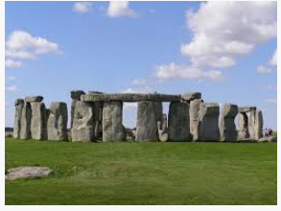  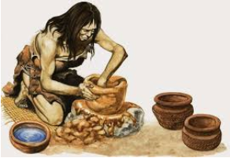  Stonehenge pottery  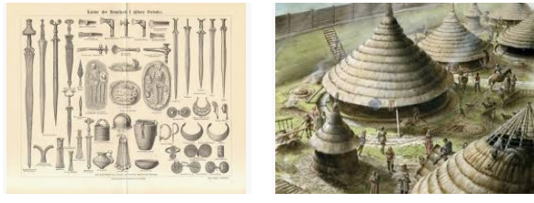  tools huts

