Year 2 Autumn 1 PSHCE – Relationships -Being Trufthul /Conflict
Key information  - It is important to always tell the truth.  - If you tell a lot of lies, people may not believe you when you are telling the truth.  - It is good to be kind to people.  - If you are unkind, people may not want to play with you.  - Teasing and bullying is very unkind.  - If I see bullying or teasing happening , I MUST tell an adult. | 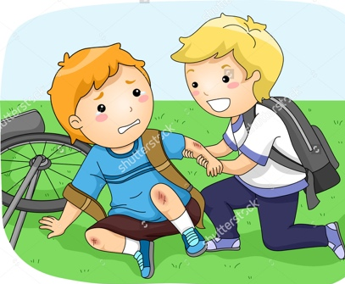  unkind  Kind  teasing  friends f
 | Vocabulary  - truth  - lie  - honest  - kind  - unkind  - fair  - unfair  - bullying.  - Teasing  - Right  - Wrong | 