Year 2 Autumn 1 Humanities – An English Village
Key facts  - Physical feature is something that is naturally created.  - Human feature is something that is built by humans.  - A village is smaller than a town.  - A village is a small community in a rural area.  - Village life refers to the life of rural people while city life refers to the life of urban people.  - A village usually has lots of open space, trees, church and a farm.  - Eynsford is a village in Kent, England.  - A castle is a fortified structure built by nobility or royalty in the Middle Ages.  - A village is quiet place compared to a city. | 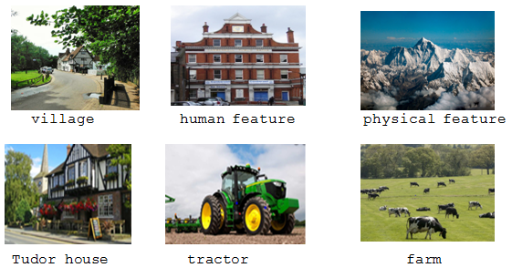
 | Vocabulary  - village  - human features  - physical features  - river  - canal  - rural/urban  - map/key  - landscape  - farm  - castle | Interesting information  - Eynsford castle is a ruined medieval fort made of stone.  - River Darent flows through the village of Eynsford.  - Tudor houses were built during the Tudor era in England between 1485-1603. | 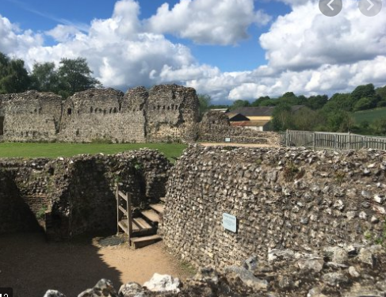  - Eynsford Castle was built by William de Eynsford between 1085-108

