Year 1 Autumn 2 Art – Line Drawing
Key facts  - A skyline is an outline of land and buildings defined against the sky  - Using a ruler helps to draw a straight line.  - You can use a ruler to draw shapes that have straight edges  - A silhouette is a dark shape or outline of someone or something visible against a brighter background  - Horizontal means from left to right going across the page  - Vertical means going up and down from top to bottom across the page  - Some cities around the world are famous for their skylines | 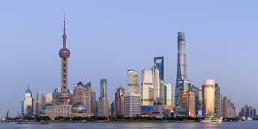  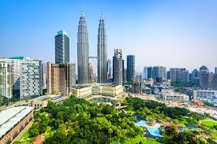  Shanghai - China  Kuala Lumpar – Malaysia  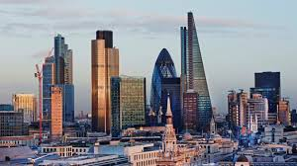  Toronto - Canada  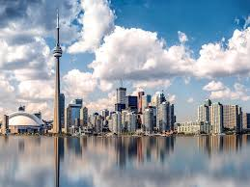  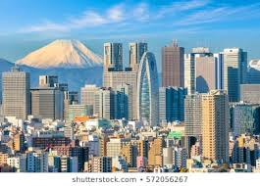  Tokyo - Japan  London - England
 | Vocabulary  - straight  - ruler  - silhouette  - vertical  - horizontal  - flat  - tower  - spire  - pointed  - edge  - curve | Patterns on the buildings  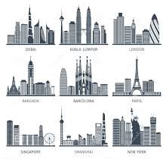  Look carefully at the lines on the buildings. You can see lots of different shapes that have been drawn.

