Year 1 Autumn 1 PSHCE – Relationships & Family
Key information  - There are different types of relationships.  - Friends are kind to you  - Some families look similar to yours.  - Some families look different to yours.  - Families come in all shapes and sizes.  - Love is what makes families the same. | family with one mum and one dad  brother sister  friends  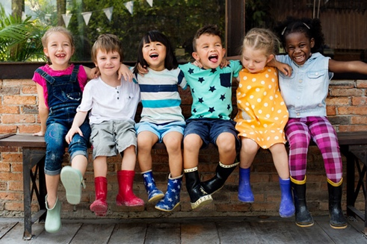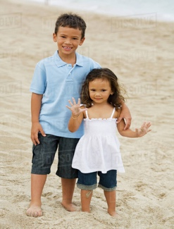  Family with two mums family family  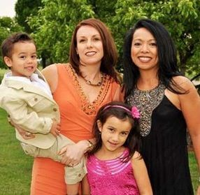  family pet  family with two dads
 | Vocabulary  - mum  - dad  - brother  - sister  - siblings  - love  - baby  - friends | 