Year 6 Spring 1 Science- Animals Including Humans
Key facts  - The circulatory system is made up of blood vessels that carry blood away from and towards the heart.  - Arteries carry blood away from the heart and veins carry blood back to the heart.  - The circulatory system carries oxygen, nutrients, and hormones to cells, and removes waste products, like carbon dioxide.  - Nutrients are transported through your blood via capillaries, tiny blood vessels that connect arteries to veins.  - Water molecules are then transported via blood circulation to be distributed all over the body, to the cells.  - Poor diet and nutrition, can lead to brain damage, organ damage, and different types of diseases.  - The body cannot store alcohol, so once it is consumed it is quickly broken down to facilitate excretion from the body.  - Therefore a healthy balanced diet, exercise and staying away from substances that can affect the body in negative ways, are important to maintain a healthy lifestyle. | 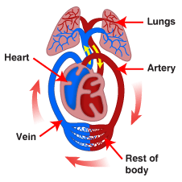
 | Scientific skills  - Plan a pattern seeking enquiry  - Record my results  - Evaluate and present my findings | Key Vocabulary  - Circulatory system  - Blood vessels  - capillaries  - mammals  - lungs  - oxygenated  - deoxygenated  - heart  - water  - nutrients

