Year 6 Spring 1 PSHCE –Drug Education
Key information  - Cannabis is an illegal drug.  - Cannabis is the most commonly used illegal drug.  - Cannabis and other illegal drugs are dangerous .  - Volatile substance abuse is very dangerous.  - We must resist negative peer pressure.  - We must always call 999 in an emergency. | 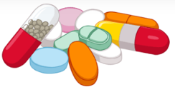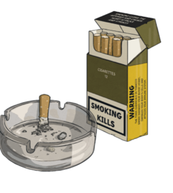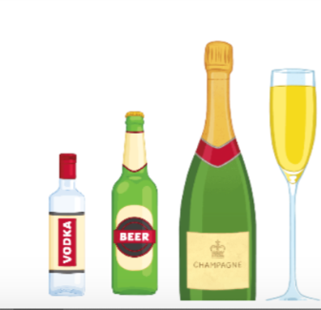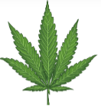  cannabis  alcohol  tobacco  drugs  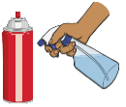  volatile substances
 | Vocabulary  - cannabis  - volatile substance  - legal  - illegal  - abuse  - inhaling  - recovery  - first aid  - dangerous  - sniffing  - recovery  - choking | 