Year 6 Spring 1 Design and Technology – Seasonal Cooking
Key facts  - Fruits and vegetables naturally ripen during a certain season each year  - When they are ripe they are at their best nutritionally and taste wise  - This is known as the fruit or vegetable being ‘in season’  - Eating seasonal produce is better for the environment as things are grown locally, rather than having to be imported from another country  - Processed foods have been altered from their natural state either for safety reasons or because it makes them easier to store or eat | 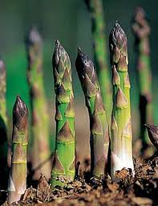  spring and summer  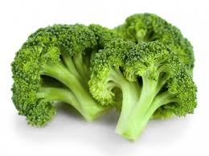  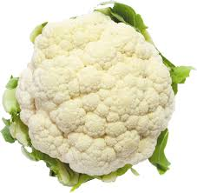  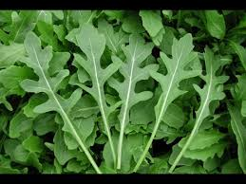  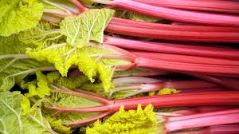  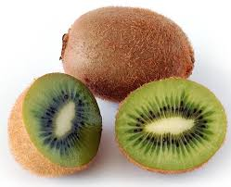
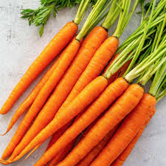
autumn and winter
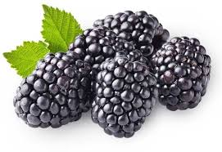
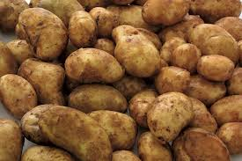
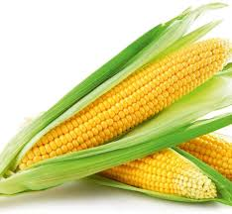
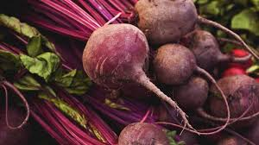
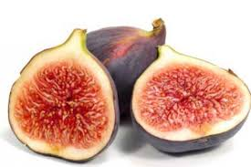

 | Vocabulary  - seasonality  - imported  - sustainable  - ripe  - reared  - caught  - processed  - spring  - summer  - autumn  - winter | Grown in the UK  Fruits Vegetables  strawberries tomatoes  raspberries cucumbers  gooseberries cabbages  blueberries parsnip  plums swede  cherries turnip  blackberries potatoes  apples runner beans  pears leeks  blackcurrants mushrooms  red currants aubergines

