Year 6 Computing Knowledge Organiser: Unit 6.5 – Text Adventures
Key Images | Key Learning
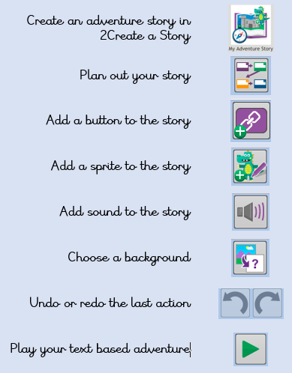 | - To find out what a text adventure is.  - To plan a story adventure.  - To make a story-based adventure.  - To introduce map-based text adventures.  - To code a map-based text adventure.
 | Key Vocabulary | Key Questions
 | - Text-based adventure  - Concept map  - Debug  - Sprite  - Function | What is a text based adventure?  A text based adventure is a type of game that uses text rather than graphics to tell the story. The player normally selects the next move from a series of text based options.  Why is it important to plan a text based adventure?  Text based adventures can often be complicated and give the player lots of options about what to do next. Planning the game ensures the player doesn’t make a decision that has no outcome.
Reference to

