Year 5 Spring 1 Science- Properties of Materials (Reversible)
Key facts  - Heating and cooling materials can bring about changes in state.  - If the change is just physical (for example mixing materials together) then it can be reversed, however, the change could be chemical and is likely to be permanent.  - When materials dissolve they form a solution. The solid material is called the solute and the liquid is called the solvent  - Sieving is defined as a method in which two or more components of different sizes are separated from a mixture on the basis of the difference in their sizes.  - Thermal conductivity is the ability to transfer heat from one object to another.  - Some materials do not transfer heat easily, but slow it down; these are poor thermal conductors but good thermal insulators.  - These materials keep things warm but also prevent cold things from warming up. | 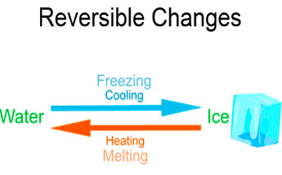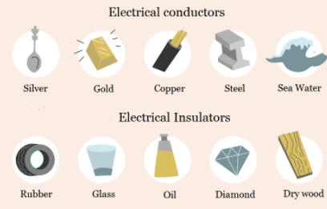
 | Scientific skills  - Plan a fair test  - Make predictions  - Use my results to draw conclusions | Key Vocabulary  - thermal conductor  - thermal insulator  - solvent  - solution  - soluble  - insoluble  - solid  - liquid  - particles  - suspensions

