Year 5 Spring 1 PSHCE –Conflicts
Key information  - Conflict is when people have a serious disagreement.  - Some conflicts can last for a long time and can be difficult to solve.  - At some point in our lives, we all come into conflict with people.  - Learning how to resolve (end) conflict is an important life skill.  - A big part of resolving a conflict is managing our emotions.  - When you are feeling angry, it can be tricky to resolve a conflict.  - It can sometimes be a good idea to walk away from a conflict and then discuss it later when everyone is feeling a bit calmer | 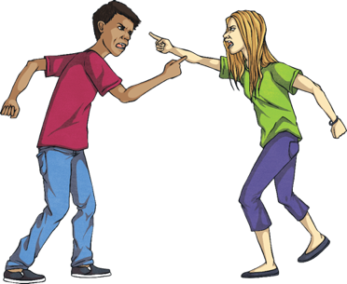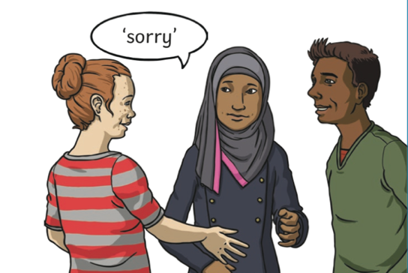  conflict/disagreement  resolutions
 | Vocabulary  - disagreement  - argument  - conflict  - resolutions  - emotions  - angry  - hurt  - stubbornness  - empathy  - compromise | 