Year 5 Spring 1 Humanities – The Water Cycle- Rivers
Vocabulary  - river  - source  - meander  - valley  - delta  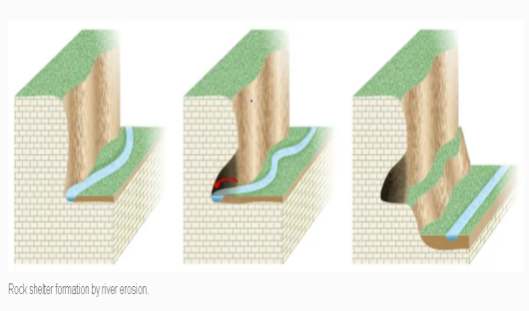  - estuary / soil erosion  - tributary / oxbow lake  - river mouth / confluence  - weathering / deposition  Key facts  - The water cycle describes the movement of water throughout the Earth's surface, atmosphere and underground.  - Water in the water cycle can exist as a solid, liquid or gas.  - River Nile in Africa is the world's longest river.  - Most rivers contain freshwater although many flow into saltwater.  - Rivers are a vital source of freshwater for life on Earth. | 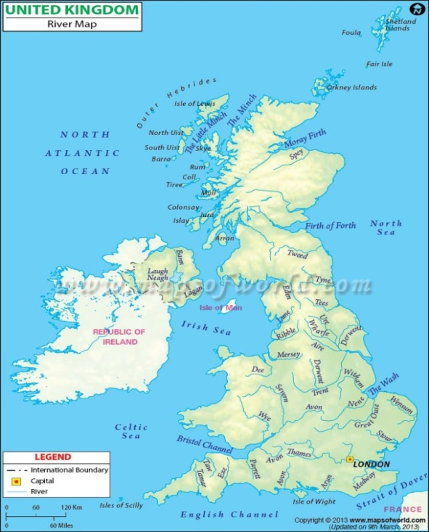  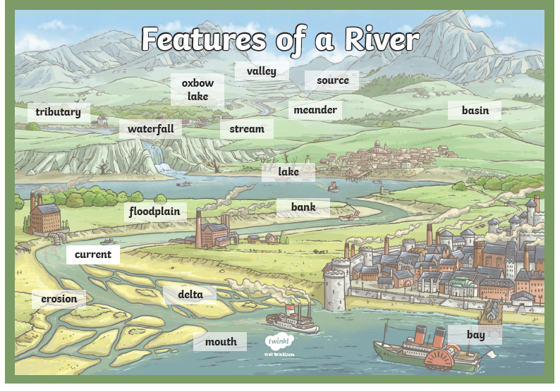  Features of a river  