Year 5 Spring 1 Design and Technology – Global Food
Key facts  - An average meal should be made up of one third carbohydrates, one third fruits and vegetables and one third split between dairy, protein and a little bit of fat  - People around the world eat a wide variety of food  - All around the world people need food to stay healthy, give us energy and help us grow  - Staple foods form the bulk of diets around the world  - These include rice, pasta, potatoes, bread, couscous and plantain  - Staple foods vary for different countries | 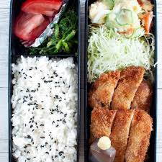  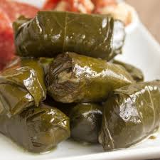  bento box - Japan  dolmades - Greece  paella - Spain  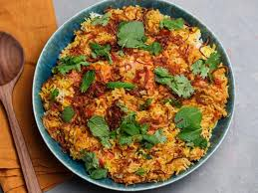  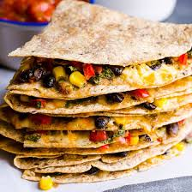  byriani - India  quesadillas – Mexico  spring rolls - China
 | Vocabulary  - climate  - flourish  - sensory  - protein  - carbohydrates  - starchy food  - nutritional  - benefits  - balanced  - hygiene  - techniques | Methods for cooking  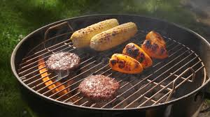  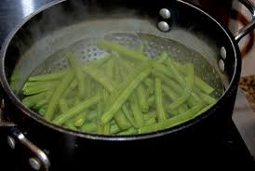  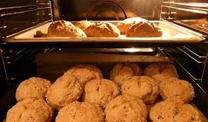  steamm  grill  bake  boil  fry  