Year 5 Computing Knowledge Organiser: Unit 5.5 – Game Creator
Key Images | Key Learning
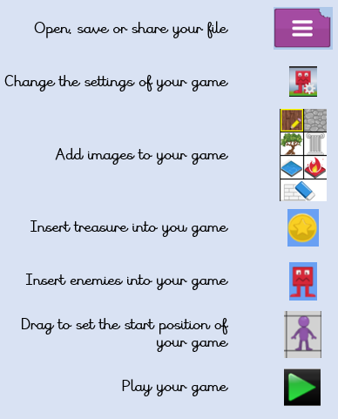 | - To set the scene.  - To create the game environment.  - To create the game quest.  - To finish and share the game.  - To evaluate their and peers’ games.
 | Key Vocabulary | Key Questions
 | - Animation  - Computer game  - Customise  - Evaluation  - Image  - Instructions  - Interactive  - Screenshot  - Texture  - Perspective  - Playability | What is the 2DIY 3D tool on Purple Mash?  2DIY 3D allows users to create a playing area, such as a maze, in 2D and then turn it into a 3D computer game. The aim is to avoid the ‘baddies’ and collect ‘treasure’.  What makes a good computer game?  A good game designer gives the player continuous challenges in a visually stimulating environment, each of which leads to another challenge, to keep the game challenging and fun.  Why is it important to continually evaluate your game?  Evaluating your game as you make it allows you to think about ways in which it can be improved. Evaluation may also involve the views of other people who play your game.
Reference to

