Year 4 Spring 1 Science- Electricity
Key facts  - A circuit must be complete for an electrical current to flow through it.  - Batteries store chemical energy and change it to electrical energy.  - A bulb in the circuit slows down (resists) the flow of electricity. More bulbs, wired in series, will slow down the flow even more, so the bulbs become dimmer.  - Materials that allow electricity to flow within them are electrical conductors, whereas Insulators are materials that do not allow electricity to flow within them.  - The purpose of a switch in a series circuit is to make it easy to open or close the electrical circuit, turning the flow of electricity on or off.  - The purpose of the wires in a series circuit is to allow the electricity to flow from one device to the next. | 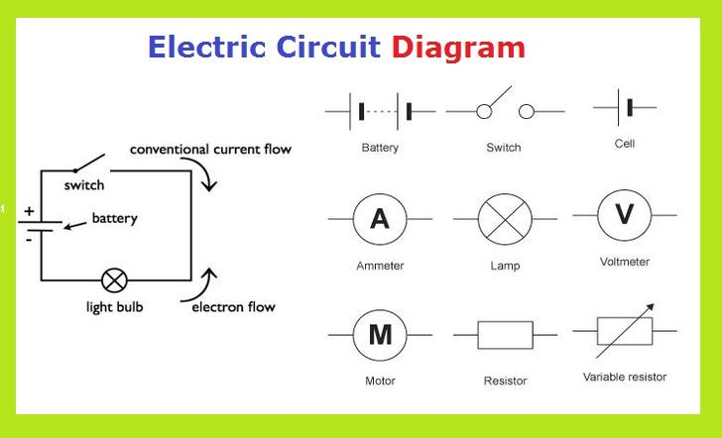
 | Scientific skills  - Investigate  - Record my results  - Use my results to make predictions | Key Vocabulary  - circuit  - conductor  - insulator  - buzzer  - bulb  - switch  - wires  - light  - sound  - heat

