Year 4 Spring 1 Humanities – UK Study- London- Physical and Human Geography
 | 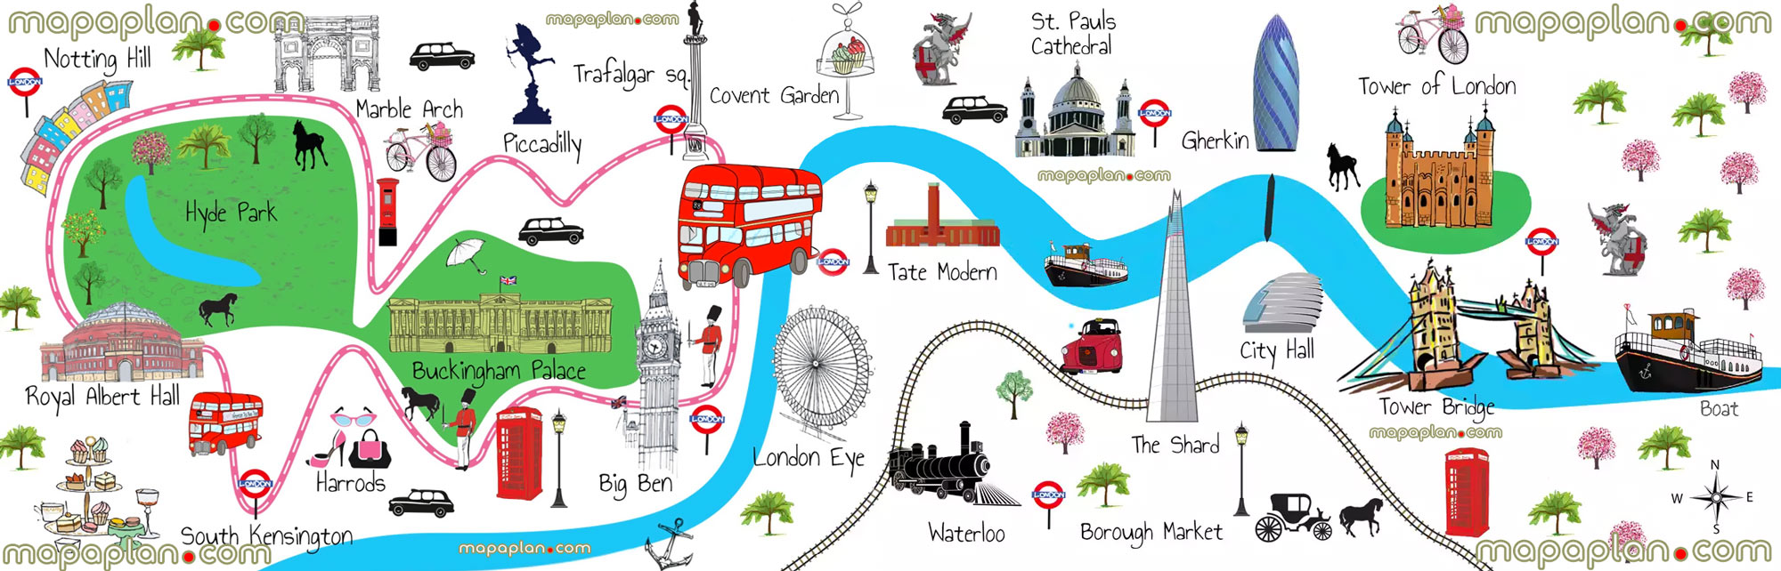
 | Vocabulary  - River Thames  - landmark  - grid  - co-ordinates  - compass point  - positional language  - Southbank  - London  - United Kingdom  - tourism /tourist /urban | 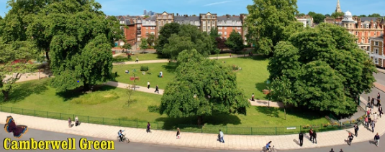  Key facts  - Physical feature is something that is naturally created.  - Human feature is something that is built by humans.  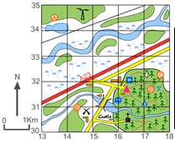  - London was the first city in the world to get the underground railway.  - London is the largest city in the United Kingdom and in Europe.  - London is the capital of England.

