Year 4 Spring 1 Design and Technology – Juggling Balls
Key facts  - Tie-dye is an old craft that is used in different forms around the world  - In India it is called bandhani  - The Shipibo and Yine tribes of the Peruvian Amazon have a resistance dying technique that is similar to tie-dye  - The oldest known images of juggling were found in the Beni-Hassan tombs of Egypt  - Juggling maintains and increases range of motion in the arms and shoulders  - It is one of the best ways to improve coordination  - The most balls ever juggled is 11. Alex Barron from the UK achieved this in April 2012.  - He managed 23 consecutive catches in what is known as a ‘qualifying’ juggling run | 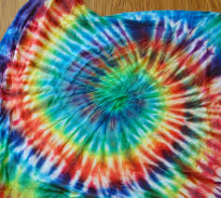  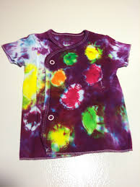  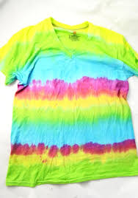  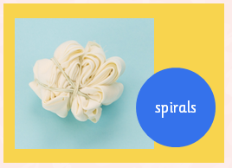
 | Vocabulary  - design brief  - product  - tie-dye  - technique  - polka dot  - spiral  - functional  - hem  - overcast stitch  - template  - aesthetic | Juggling tips  - Start with one ball and pass it from one hand to the other and then progress to using two balls  - You must keep your eye on the balls as you juggle  - Beanbags are good for beginners to use when learning to juggle  - Use balls that do not roll away!  - Scooping is a technique to make juggling smooth

