Year 3 Spring 1 Science- Forces and Magnets
Key facts  - Magnets are made with metals containing iron, cobalt, nickel or steel that has been exposed to a magnetic field.  - Magnets have two poles, a north and a south pole.  - When opposite poles are near to each other they will attract, whereas when the same poles are near to each other they will repel.  - Magnetic materials can become magnetised when near or touching another magnet, these materials are attracted to both ends of the magnet and are never repelled.  - Metals need to contain steel, iron, nickel or cobalt to be magnetic.  - There are many different types of magnets and each can react in different ways; some include, horseshoe magnets, disc magnets, ring magnets, bar magnets etc.  - Friction is a force between two surfaces that are sliding, or trying to slide, across each other, for example, when you try to push a book along the floor, friction makes this difficult.  - Friction always works in the direction opposite to the direction in which the object is moving, or trying to move. | 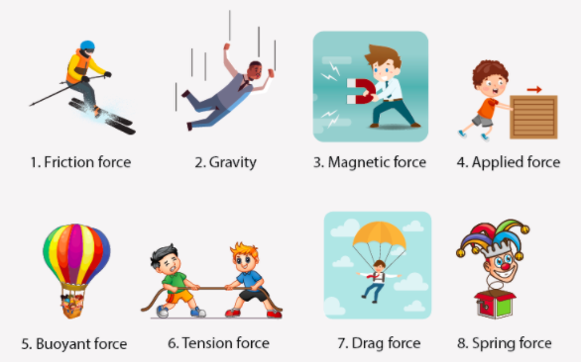
 | Scientific skills  - Make careful observations  - Set up a fair test  - Record our findings  - Say what our results show | Key Vocabulary  - magnets  - attract  - repel  - North and South Pole  - twist  - magnetic  - magnetic field  - push  - pull  - friction

