Year 3 Spring 1 Humanities – Roman Empire and its Impact on Britain
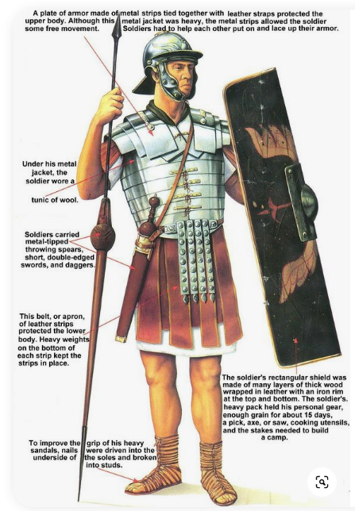  Roman soldier | 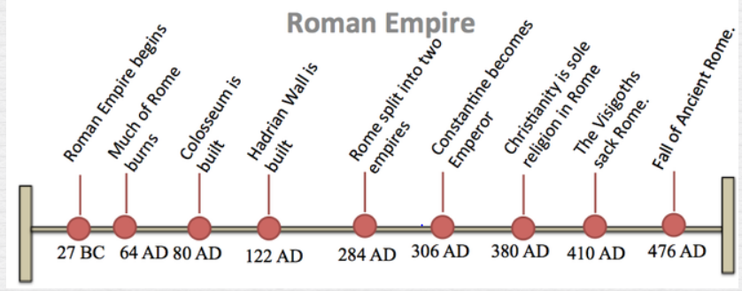  Timeline  goblet  coin  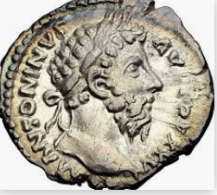  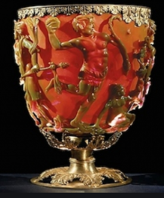
 | Vocabulary  - Roman  - Boudicca  - soldier  - empire  - Celts/ Iceni  - Julius Caesar  - invaders  - legion  - emperor  - Claudius  - rebellion  - roman bath  - artefacts | 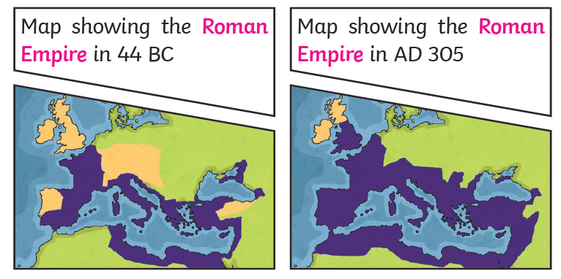  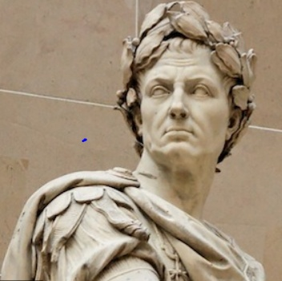  Julius Caesar Boudicca

