Year 3 Computing Knowledge Organiser: Unit 3.6 – Branching Dataases
Key Images | Key Learning
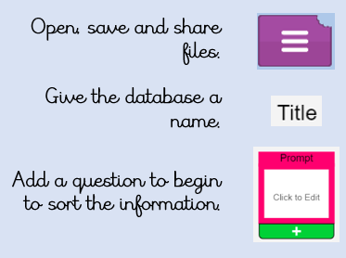 | - To sort objects using just ‘yes’ or ‘no’ questions.  - To complete a branching database using 2Question.  - To create a branching database of the children’s choice.
 | Key Vocabulary | Key Questions
 | - Branching database  - Data  - Database  - Question | What is meant by data?  Facts about something; data can be words, numbers or pictures. For example, the class register contains data about the names, addresses and attendance of the children in the class.  What is a database?  A collection of data organised in such a way that it can be searched, and information found easily. Database usually refers to data stored on computers.  What is a branching database?  Used to classify groups of objects. It is used to help identify the objects by answering questions with either ‘yes’ or ‘no’. Branching databases can also be called binary trees.
Reference to

