Year 2 Spring 1 Science- Animals Including Humans
Key facts  - Exercise helps the human body stay healthy by helping your muscles, heart and lungs get stronger.  - To stay healthy, you also need a balanced diet.  - A balanced diet is made up of a mix of fruit and vegetables, dairy, protein, fats and sugars and carbohydrates.  - Fruit and vegetables must always take up the largest part of your plate of food (5 a day).  - Good hygiene is also important to have a healthy body, for example washing your hands stops germs from spreading.  - Being unhygienic can lead to negative results, for example coughing without covering your mouth can spread germs.  - Each animal group has different survival needs as they go through different stages in their life cycle.  - For example a baby uses milk as its diet, whereas as a child you need to combine all different food groups to get the nutrition you need to grow and keep healthy.  - A fish can not survive on land as it does not have lungs, instead it uses its gills to be able to breathe underwater. | 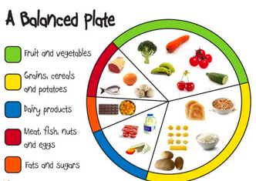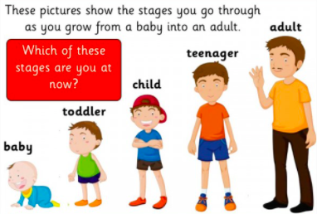
 | Scientific skills  - Ask questions  - Observe closely  - Test an idea  - Record my results | Key Vocabulary  - Life cycle  - Fish  - Birds  - Amphibians  - Reptiles  - Mammals  - Exercise  - Balanced diet  - Muscles  - Hygiene

