Year 2 Spring 1 RE – Sikhism
Key facts  - Sikhism began in India in the 15th Century by Guru Nanak.  - As the first guru of Sikhism, Guru Nanak contributed 974 hymns to Guru Granth Sahib  - He thought it was wrong to treat people differently because of their race, gender or social status.  - He believed that everyone should work hard, be honest, always help those in need and remember God.  - He travelled thousands of miles on foot to spread God’s message of oneness and purity.  - He started the Sikh idea of langar as a child.  - Guru Nanak was born a Hindu and was always curious about God at a young age.  - When he was 28 years old, he disappeared for three days. Everyone feared he had died while washing in the river.  - He reappeared saying he had been with God and that he would be following God’s path from now on. | 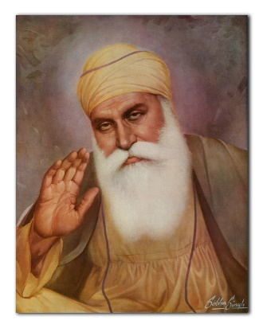  Guru Granth Sahib  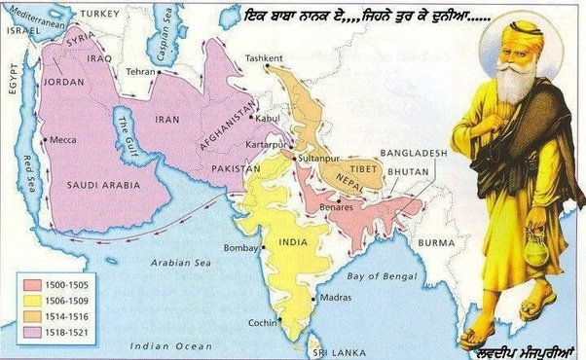  Guru Nanak Dev Ji  Map of Guru Nanak’s travels
 | Vocabulary  - Guru  - Guru Nanak  - Guru Granth Sahib  - langar  - gurdwara  - equality  - purity  - gender  - Sikhs | 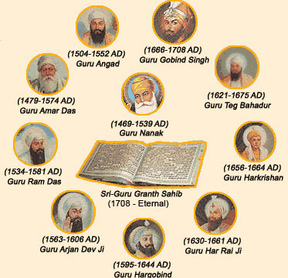  Sikh Gurus

