Year 1 Spring 1 Science- Animals Including Humans
Key facts  - Reptiles are cold-blooded, have scales and usually lay eggs.  - Fish are similar to reptiles but also have fins and use gills to breathe under water.  - Birds are warm blooded, lay eggs and have feathers and wings.  - Amphibians are able to live on land and in water but their skin stays wet, they are also cold-blooded and lay their eggs in water.  - Mammals make milk, are warm blooded and have hair or fur; humans are part of this group.  - Carnivores are animals that eat only meat, herbivores eat only plants but omnivores eat both.  - Humans and other mammals, have five senses.  - Some senses are stronger than others, for certain animals.  - Humans use eyes to see, ears to hear, nose to smell, tongue to taste and hands to touch. | 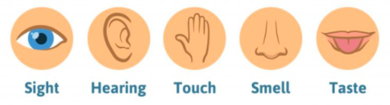
 | Scientific skills  - Ask questions in science lessons  - Observe  - Collect information  - To record my results | Key Vocabulary  - bird  - fish  - amphibians  - reptiles  - mammals  - carnivore  - herbivore  - omnivore  - feathers  - gills

