Year 1 Spring 1 RE – Sikhism
Key facts  - Naam Karan is a Sikh baby naming ceremony.  - The baby is welcomed into the Sikh faith. Naam Karan takes place in a gurdwara.  - The Sikh holy book (the Guru Granth Sahib) is opened at random. The first letter of the first word on that page is chosen to be the first letter of the baby’s name.  - Once the name has been chosen, everybody cheers.  - For their second name, girls are called Kaur (princess) and boys are called Singh (lion).  - Everyone who attends the Naam Karan gets to taste a special pudding, called Karah parshad, which is made from flour, semolina, butter and sugar.  - Naam Karan takes place whenever the mother and baby are fit and healthy.  - The Mool Mantar is said to thank God for the precious gift of life.  - The baby is given a spoonful of Amrit mixture. | 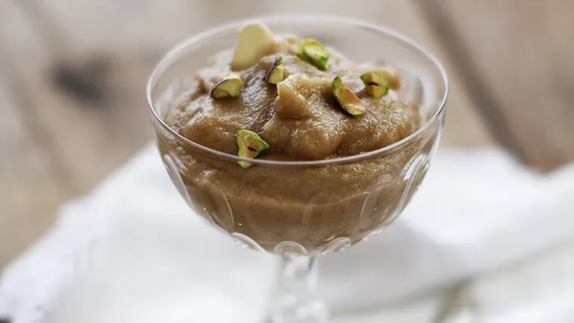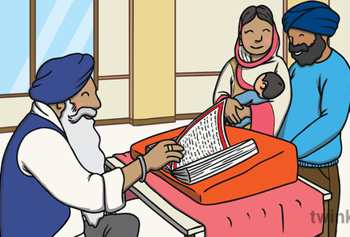  Karah parshad Naam Karan  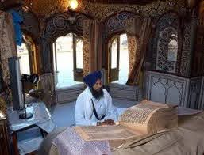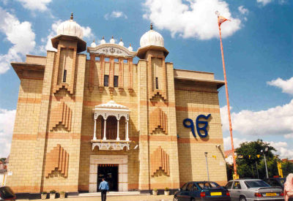  Guru Granth Sahib gurdwara.
 | Vocabulary  - Naam Karan  - gurdwara.  - Guru Granth Sahib  - Kaur (princess)  - Singh (lion)  - Karah parshad  - Mool Mantar  - Amrit | 