Year 1 Computing Knowledge Organiser: Unit 1.7 – Coding
Key Images | Key Learning
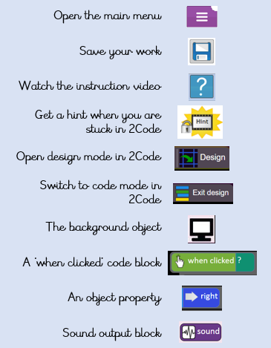 | - To understand what coding means.  - To use design mode to set up a scene.  - To add characters.  - To use code blocks to make the character perform actions.  - To use collision detection.  - To save and share work.  - To know the save, print, open and new icon.
 | Key Vocabulary | Key Questions
 | - Action  - Background  - Button  - Character  - Code block  - Code Design  - Coder  - Coding  - Collision Detection  - Command  - Design Mode  - Input  - Object  - Program  - Properties  - Scale  - Stop command  - Sound  - When clicked  - When Key | What is coding?  Writing instructions in a way that a computer can interpret them to make a program.  How can you make characters move in a 2Code program?  In design mode, add a character. Change properties such as the name and scale. 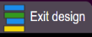Exit from design mode and drag your character’s code block into the coding window. From the properties menu, select right, left, up or down.  Why is it useful to design before coding?  It helps you to get a clear idea of what you want your program to do. You can use the design to decide which objects you need to add, what to call them and what actions they should perform.
Reference to

