Year 1 Computing Knowledge Organiser: Unit 1.6 – Animated Story Books
Key Images | Key Learning
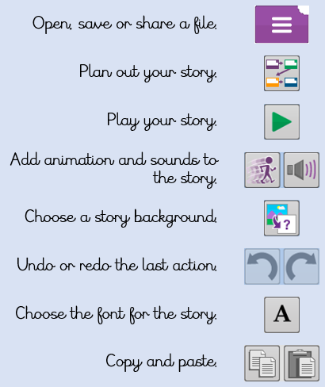 | - To introduce e-books and the 2Create a Story tool.  - To add animation to a story.  - To add sound to a story, including voice recording and music the children have composed.  - To work on a more complex story, including adding backgrounds and copying and pasting pages.  - To share e-books on a class display board.
 | Key Vocabulary | Key Questions
 | - Animation  - E-Book  - Font  - File  - Sound Effect  - Display Board | What is 2Create a Story?  With 2Create a Story you can create ebooks including animated pages, sounds, narration and music.  What is an animated story?  An animated story is a story where the images in the foreground can move in a variety of ways.  How can I make my story better?  As well as adding animation to the story it can be improved by adding sounds or sound effects to the different pages.
Reference to

