Year 6 Computing Knowledge Organiser: Unit 6.3 – Spreadsheets
Key Images | Key Learning
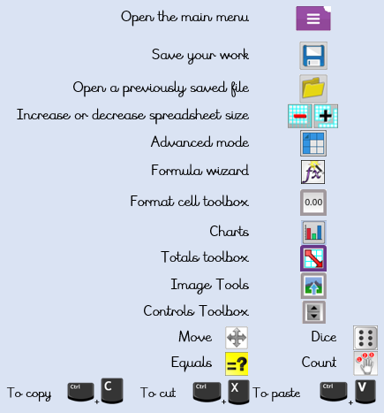 | - To use a spreadsheet to investigate the probability of the results of throwing many dice.  - Using the formula wizard to add a formula to a cell to automatically make a calculation in that cell.  - To create graphs showing the data collected.  - To type in a formula for a cell to automatically make a calculation in that cell.  - Using a spreadsheet to create computational models and answer questions.
 | Key Vocabulary | Key Questions
 | - average  - advance mode  - copy and paste  - columns  - cells  - charts  - count (how many) tool  - dice  - equals tool  - formula  - formula wizard  - move cell tool  - random tool  - rows  - spin tool  - spreadsheet  - timer | How would you add a formula so that the cell shows the total of a column of cells?  Use the formula wizard advanced total tool or type a formula into the cell by using the ‘=’ symbol, mathematical operators and cell references.  What is a computational model and what it can be used for?  Modelling in Computing means creating or using a simulation (a model) of a real-life situation, on a computer. It represents the data of a situation. For example; budgeting for a party; working out how big a field needs to be for a certain number of animals; working out the best price for an item or using the existing data to predict what time your shadow will be a certain length.  If you were going to use a spreadsheet to plan your dream holiday. What data would you collect to cost the trip?  Ideas could include:  - Include travel; comparing the cost of different methods, airports, airlines, different companies and discounts such as rail cards.  - Cost of accommodation of different types, trips out, food, passports, immunisations.

