Year 4 Computing Knowledge Organiser: Unit 43 – Spreadsheets
Key Images | Key Learning
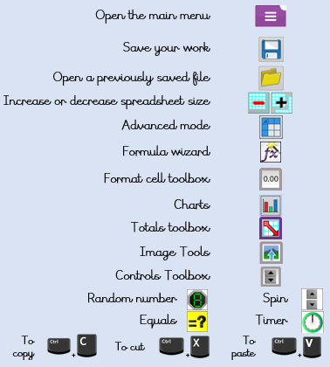 | - Formatting cells as currency, percentage, decimal to different decimal places or fraction.  - Using the formula wizard to calculate averages.  - Combining tools to make spreadsheet activities such as timed times tables tests.  - Using a spreadsheet to model a real-life situation.  - To add a formula to a cell to automatically make a calculation in that cell.
 | Key Vocabulary | Key Questions
 | - average  - advance mode  - copy and paste  - columns  - cells  - charts  - equals tool  - formula  - formula wizard  - move cell tool  - random tool  - rows  - spin tool  - spreadsheet  - timer | How would you add a formula so that the cell shows the percentage score for a test?  Click on the cell where you want the percentage score to be displayed then click the formula wizard button. Click on the cell that contains the score. Choose the ÷ operation then click on the cell that shows what the test was out of. Click OK.  Which tools would you use to create a timed times tables test in 2Calculate?  You could use the random tool, the spin tool, the equal tool and the timer tool.  Give an example of the data that could be best represented by a line graph.  Data where both axes will contain continuous data so that you can see trends in the data. Such as ages and heights, time and temperature, years and costs.  Explain what a spreadsheet model of a real-life situation is and what it can be used for?  It represents the data of a situations for example budgeting for a party, working out how big a field needs to be for a certain number of animals, working out how to spend your pocket money over time.

