Year 2 Computing Knowledge Organiser: Unit 2.2 – Online Safety
Key Images | Key Learning
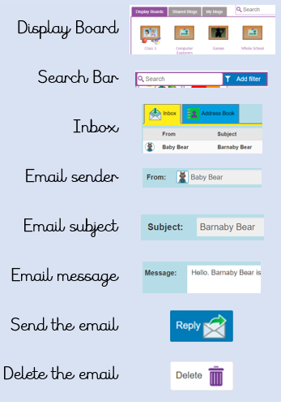 | - To know how to refine searches using the Search tool.  - To use digital technology to share work on Purple Mash to communicate and connect with others locally.  - To have some knowledge and understanding about sharing more globally on the internet.  - To introduce email as a communication tool using 2Respond simulations.  - To understand how we should talk to others in an online situation.  - To open and send simple online communications in the form of email.  - To understand that information put online leaves a digital footprint or trail.  - To identify the steps that can be taken to keep personal data and hardware secure.
 | Key Vocabulary | Key Questions
 | - search  - displayboard  - internet  - sharing  - email  - attachment  - digital footprint | Why is a search bar useful?  The search bar on Purple Mash or on a website helps the user to quickly find the resources they are looking for.  What is an email?  An email is a way of sending messages electronically from one device to another. An email can have items such as pictures and videos attached to it.  What is meant by my Digital Footprint?  A digital footprint is a term used to describe the traces of yourself that you leave online. With every website you visit, you leave a trail or footprint showing that you've been there.

