Year 2 Autu,mn 1 RE – Hinduism
Key facts  - Krishna Janmashtami, , is an annual Hindu festival that celebrates the birth of Krishna,  - Krishna is the eighth avatar of Vishnu.  - Krishna is believed to be born in the year 3228BC  - The festival is usually between August and September  - It is celebrated with dance-drama enactments of the life of Krishna, singing songs and fasting all night.. They have a festival on the following day.  - People get together to burst a Handi (clay pot) full of Dahi (yoghurt) set at a height.  - They make a human tower to get to the pots.  - Several young men and women take part in the Janmashtami ritual. | 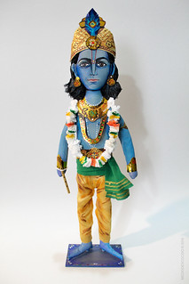  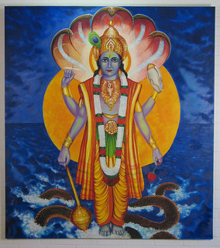  Vishnu  Temple  Krishna  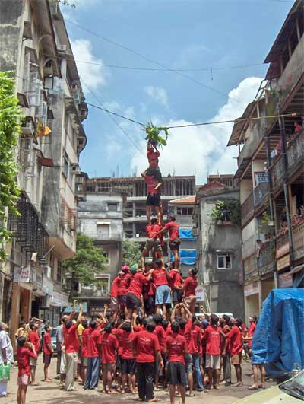  Janmashtami  Tower  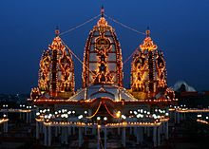
 | Vocabulary  - Hindu  - Krishna  - Krishna Janmashtami  - Vishnu  - avatar  - vigil  - festival  - month of Saravana  - temple  - bhajans (traditional songs) | Hinduism is the oldest of the world’s  religions. It is now practised all over the world but originated in South East Asia. The religion is over 4000 years old  Krishna is the most popular avatar of Vishnu and is worshipped as a god in his own right. Krishna is often shown playing a flute.

