Year 5 Autumn 2 PSHCE – Stereotypes
Key information  - A stereotype is an idea or belief held by a person, about an individual or group, based on limited information.  - There are many ways for us to stay healthy.  - We should never judge a person or a group just because of the way they look, their gender, the job they have, their age or their likes and dislikes.  - Ideas that people have about others are not always. correct | 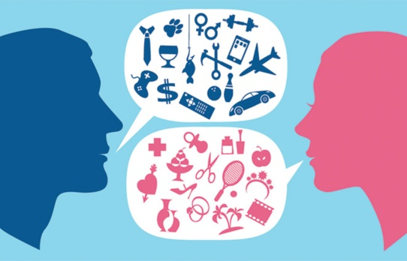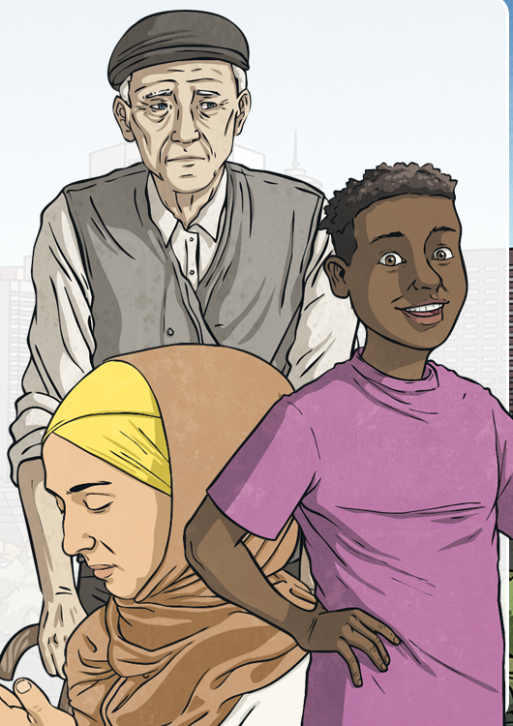  Cultural stereotypes  Gender stereotypes
 | Vocabulary  - stereotypes  - challenge  - gender  - prejudice  - hate crimes  - cultural stereotypes  - myth | 