Year 3 Autumn 2 PSHCE – Types of Relationships
Key information  - It is important to be responsible in and out of school.  - Being irresponsible can get you in to trouble.  - There are different ways that you can look after yourself.  - We should look after  objects and belongings.  - There are different people that help look after you.  - We can help look after people/pets.  - Sometimes looking after someone/ something can make us feel good.  - It is irresponsible and unkind to not look after a pet properly. | 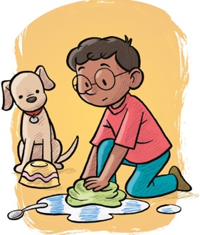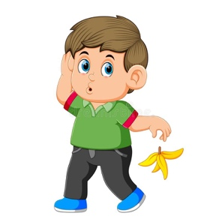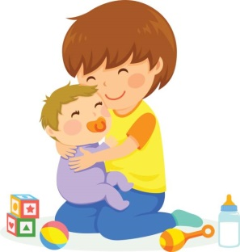  caring  irresponsible  responsible d  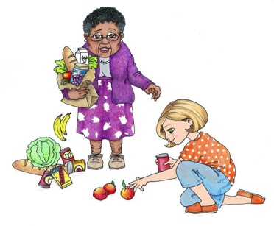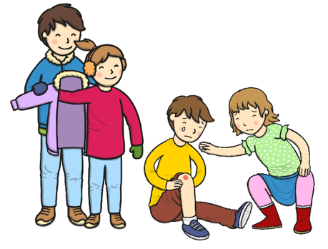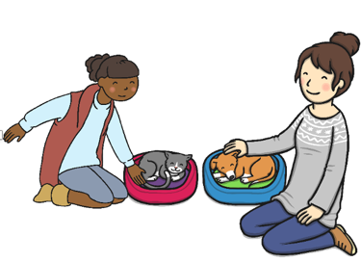  looking after pets  looking after each other  helpful
 | Vocabulary  - responsible  - irresponsible  - care  - feelings  - right  - helpful  - unhelpful  - wrong | 