Year 6 Autumn 2 Art – Printing: Victorian Designers
Key facts  - William Morris is best known as the 19th century’s most celebrated designer  - His work dramatically changed the fashion and ideology of the era  - He was born in Walthamstow in March 1834  - He is most famous for textiles and wallpapers  - He used lots of images of natural and flowers in his designs  - Victorian styles of wallpaper and textiles reflected very elaborate prints  - Motif – a decorative image or design, especially a repeated one forming a pattern | 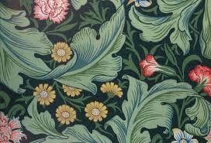  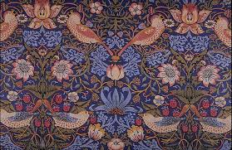  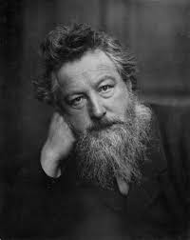  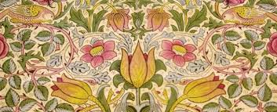  wallpaper examples  William Morris
 | Vocabulary  - aesthetic  - motif  - pattern  - Victorian  - Medieval  - rotation  - reflection  - symmetry  - repetition  - border  - overlapping | Printing blocks  - printing blocks have a raised design  - design can be cut out or stuck onto a base  - colour is then added to create the printed image on the raised sections  