Year 6 Spring 1 Humanities – Migration
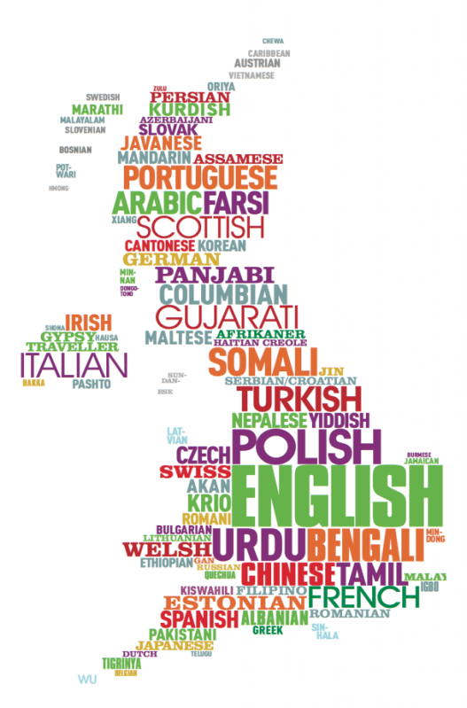  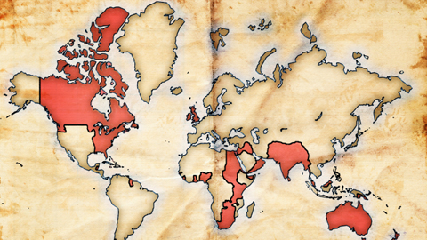  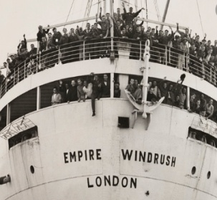  Colonies of the British Empire | Key facts  - The British Empire came to be in the 16th century.  - The end of the Empire came in the years after World War 2, with most of Britain’s colonies ruling themselves independently by the late 1960’s.  - The Royal Navy which controlled the seas lanes between Britain and her overseas possessions was very powerful and this helped Britain to become a huge, global empire.  - People immigrate for many reasons, some which include economic or political reasons, family reunification, natural disasters or the desire to change one’s surroundings.  - Evidence suggests that international migration can boost aggregate income in high-income host countries over the long term.
 | Vocabulary  - Windrush  - migration  - empire /colony  - immigrant  - emigrate  - import  - export  - commonwealth  - society / multicultural  - economy | - Migration is the movement of people from one place to another with the intention of settling.  - An empire is a group of states or countries ruled over by a single monarch or a sovereign state.  - An immigrant is a person who comes to live permanently in a foreign country.

