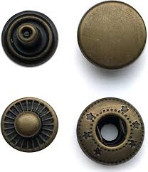
Year 6 Autumn 1 Design and Technology – Felt Phone Cases
Key facts  - Motorola was the first company to make a mobile phone  - On April 3rd 1973 Martin Cooper made the first phone call on a hand held device  - The first mobile phones for public use were available in 1984  - Felt is a textile material that is produced by matting, condensing and pressing fibres together  - Felt can be made of natural fibres such as wool or animal fur  - It can also be made from synthetic fibres such as petroleum based acrylic or wood pulp-based rayon | 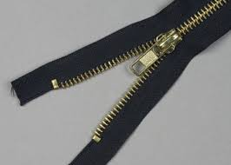  zip  buttons  poppers  hooks and eyes  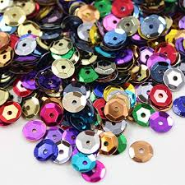  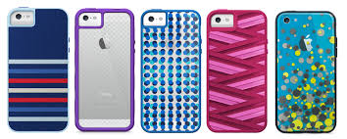  sequins  decorative cases
 | Vocabulary  - design criteria  - functionality  - aesthetics  - specification  - innovative  - annotate  - pattern  - template  - fastenings  - decoration  - felt | Types of stitches  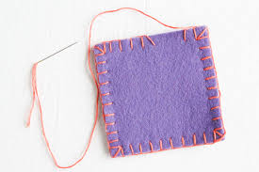  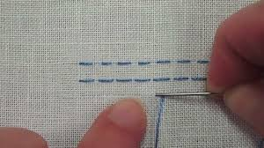  blanket running  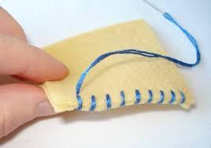  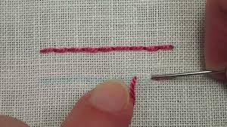  back whip

