Year 5 Autumn 1 Humanities – Windrush
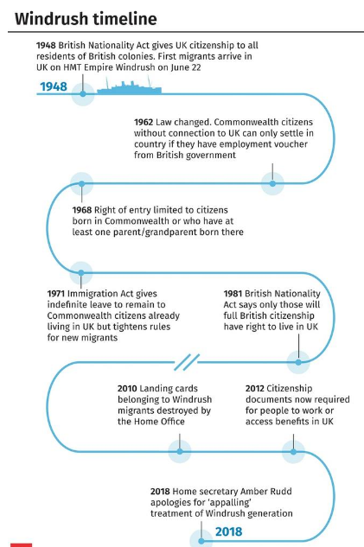  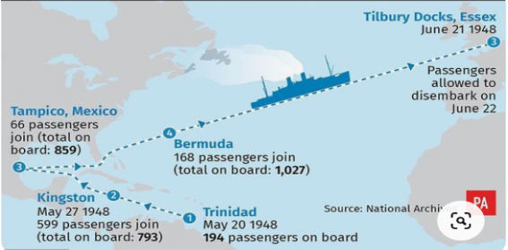  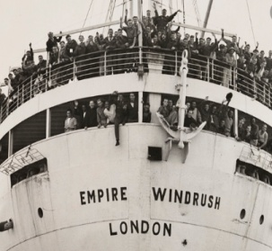  Key dates/timeline | Key facts  - The Empire Windrush arrived at Tilbury on 22nd June 1948, carrying 493 passengers from Jamaica wishing to start a new life in the United Kingdom.  - The passengers were the first large group of West Indian immigrants to the UK after the Second World War.  - When the passengers arrived at port, they were faced with discrimination and racism because of the colour of their skin.  - The Windrush scandal is a 2018 British political scandal concerning people who were wrongly detained, denied legal rights and some were wrongly deported from the UK by the Home Office.  - The Windrush generation bought an explosion of dance, art, writing and music which would transform British culture.
 | Vocabulary  - Windrush  - migration  - Empire  - immigrant  - emigrate  - import  - export  - commonwealth  - culture  - society  - economy  - colony | Key facts  - Migration is the movement of people from one place to another with the intention of settling.  - An empire is a group of states or countries ruled over by a single monarch or a sovereign state.  - The Commonwealth of Nations is a political association of 54 member states.  - An immigrant is a person who comes to live permanently in a foreign country.

