Year 5 Autumn 1 PSHCE – Relationships
Key information  - Not all families look the same.  - There are different issues that can affect a family.  - Divorce is when a married couple decide that the no longer what to be married to each other.  - In a divorce, the couple sign a legal piece of paperwork, which means that they are no longer married.  - Divorce is never the child’s fault.  - Bereavement is the experience of losing someone close to you through death.  - Being separated from someone you care about can be scary.  - There are different people to help support us when we lose /are separated from someone. | 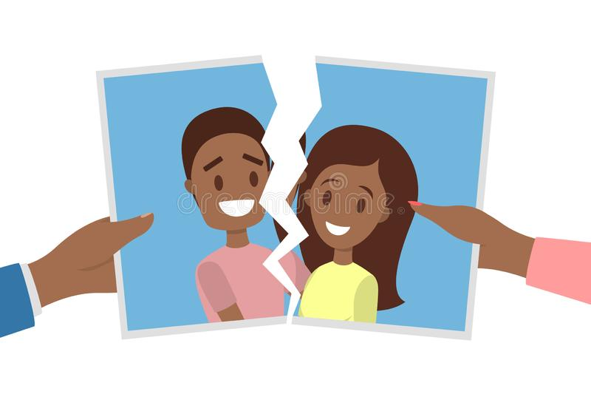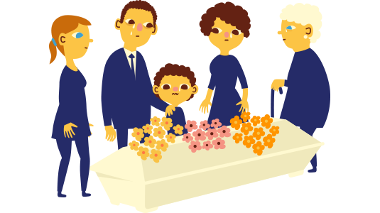  bereavement  divorce  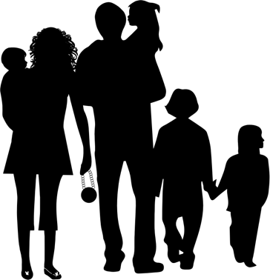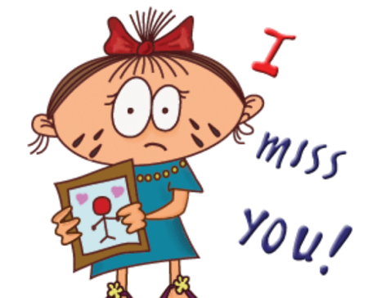  separation  family
 | Vocabulary  - Family  - divorce  - grief  - emotions  - bereavement  - death  - support  - hurt  - separation. | 