Year 5 Autumn 1 Design and Technology – Programming Adventures
Key facts  - The first toy robot was believed to be a yellow, boxy robot from Japan  - It is believed to have emerged in the 1930’s  - Later most toy robots were made in America  - Programmable toys can use buttons on the device or separate handsets  - Today programmable toys can be used with voice controls  - Input – data that a computer/device receives  - Output – data that a computer/device sends | 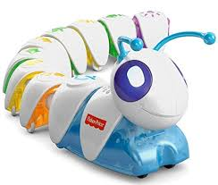  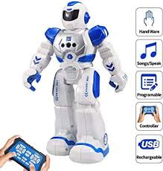  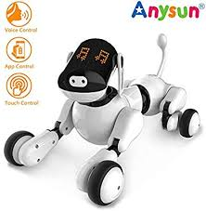  robot  dog  caterpillar  crocodile  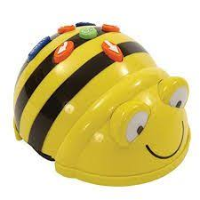  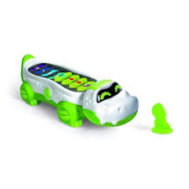  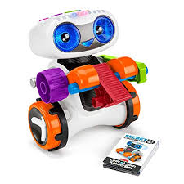  coding toys  Beebot
 | Vocabulary  - floor robot  - input  - output  - Beebot  - adventure  - materials  - properties  - obstacles  - design criteria  - evaluate | Adventure maps  