Year 4 Autumn 1 Design and Technology – The Great Bread Bake Off
Key facts  - Warburtons are the second biggest grocery brand after Coca Cola  - They deliver to 18,500 retail customers a week  - They are the most recognised bread brand in the UK  - They are a family bakery, founded in 1876 in Bolton  - Traditionally bread was made by hand, but today many people have bread making machines at home  - Some people are allergic to the gluten in bread.  - These people are known as Coeliac  - Yeast makes the bread rise | 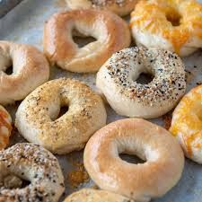  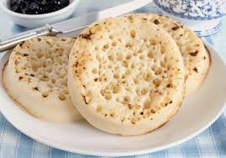  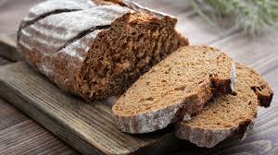  crumpet  rye  bagel  flat bread  English muffin  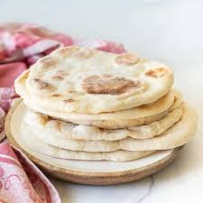  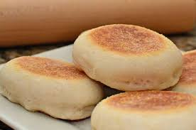  foccacia  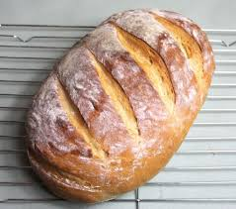  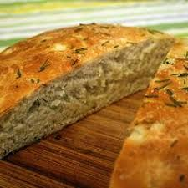  bloomer
 | Vocabulary  - texture  - appearance  - flavour  - market  - yeast  - knead  - dough  - rise  - brand  - industry  - pioneer | Bread around the world  - Baguette – France  - Ciabatta – Italy  - Naan – India  - Tortilla – Mexico  - Pita – Greece  - Pretzel – Germany  - Borodinsky – Russia  - Brioche – France  - Arepa – Colombia

