Year 3 Autumn 2 Art – Drawing
Key facts  - A comic strip is a sequence of drawings arranged in interrelated panels  - It displays brief humour or form of narrative with text in balloons and captions  - Although several cartoon characters appeared in American newspapers in the early 1890’s, the strip “The Yellow Kid”, created by Richard Outcault is often cited as the first true comic strip  - Colour wash – paint that has been thinned to create a subtle colour, usually for a background | 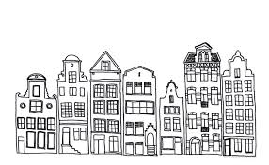  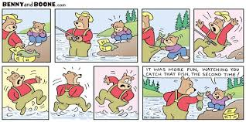  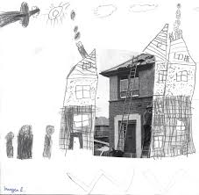  line drawings of buildings  comic strip  extended drawing
 | Vocabulary  - sequence  - comic  - strip  - colour wash  - detail  - lines  - imagine  - invent  - pretend  - create  - exaggerate | Five main skills of drawing  - recognise edges, lines and angles  - recognise spaces  - calculate proportion and perspective  - understand shadow, highlights and graduations of tone  - the ability to put them all together, which comes with practise

