Year 3 Autumn 1 Design and Technology – Let’s Go Fly a Kite
Key facts  - Kites were invented in Asia  - It is thought that the earliest use of kites was among the Chinese 2,800 years ago.  - Kites today are usually made form plastic and polyester  - Very expensive kites can be made from silk  - Kites are a popular toy among children on a windy day  - In 1848 Homan Walsh played a key role in building the first suspension bridge across the Niagra river between the United States of America and Canada  - Homan J Walsh died on 8th March 1899 | 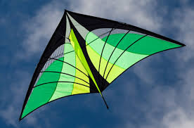  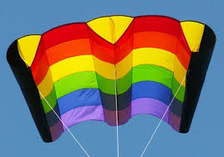  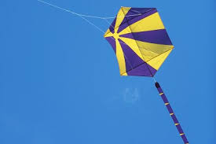  sled kite  delta kite  rokkakus kite  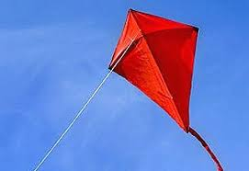  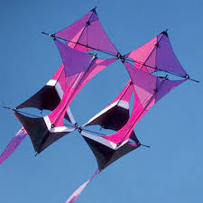  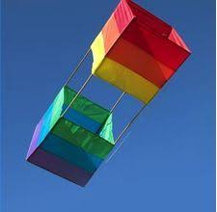  diamond kite  cellular kite  box kite
 | Vocabulary  - function  - tail  - sails  - line  - tow point  - bridle  - spars  - keel  - frame  - design | Parts of a kite  - Bridle – the arrangement of the strings that go between the kite  - Line – prevents the kite from flying away  - Spars – give the kite a structure  - Sails – directs the air to give the kite lift  - Keel – similar to the bridle, it acts like a rudder  - Tail – adds drag to keep the kite pointed into the wind  - Tow point – connection point from the line to the bridle

